Table of Contents
Table of Contents ii
Revision History ii
1. Introduction 1
1.1 Purpose 1
1.2 Document Conventions 1
1.3 Intended Audience and Reading Suggestions 1
1.4 Project Scope 1
1.5 References 1
2. Overall Description 2
2.1 Product Perspective 2
2.2 Product Features 2
2.3 User Classes and Characteristics 2
2.4 Operating Environment 2
2.5 Design and Implementation Constraints 2
2.6 User Documentation 2
2.7 Assumptions and Dependencies 3
3. System Features 3
3.1 System Feature 1 3
3.2 System Feature 2 (and so on) 4
4. External Interface Requirements 4
4.1 User Interfaces 4
4.2 Hardware Interfaces 4
4.3 Software Interfaces 4
4.4 Communications Interfaces 4
5. Other Nonfunctional Requirements 5
5.1 Performance Requirements 5
5.2 Safety Requirements 5
5.3 Security Requirements 5
5.4 Software Quality Attributes 5
6. Other Requirements 5
Appendix A: Glossary 5
Appendix B: Analysis Models 6
Appendix C: Issues List 6

Introduction

Purpose
This SRS specifies the software requirements for release 1.0 of the Grading System. This document will be used by members of the project team that will implement and verify the correct functioning of the system. All requirements specified here are high priority and are committed for release 1.0 unless otherwise noted.

Document Conventions
All items from the Data Dictionary are in bold. All elements referring to a part of the Appendix have a reference to the relevant part of the Appendix immediately following them i.e. (See Appendix A: Glossary).

Intended Audience and Reading Suggestions
This SRS consists of relevant requirements for both customers and developers. This document contains all of the project information consolidated into a single document to make understanding the project as a whole easier and quicker than having multiple documents to reference.

Project Scope
The Grading System is a web-based grading system designed to provide admin, teachers and teacher assistants with an easy, quick way to store grades and allow students to quickly access their grades. A detailed project description is available in section 3 of Vision and Scope Document for CGrading System [1].

The Student Registration Web Application provides basic functionality to add, list, edit and delete the following records: students, teachers, courses, results, payments, locations, and schedule entries. To accomplish this it makes use of various technologies: eclipse, tomcat, java, jsp, jstl, spring, spring web-mvc, hibernate, oracle, html, and javascript.

Overall thisis a very substantial project which helped solidify the understanding of the various technologies used to create it, especially spring and hibernate.

References

Overall Description

Product Features
- Student
  - Create {/ View / Edit / Delete} and List all students
  - Create {/ View / Edit / Delete} and list all courses
  - Create {/ View / Edit / Delete} grades
  - Notify students about grading by email
  - Display transcript for students
  - Login {/ Logout} to the system

- For next release:
  - The system should be in English and French. We should be able to switch the language

User Classes and Characteristics

Database
Students

Grading System

Courses
Marks
Receive Grade, Gradable, Course, Group and User Data

Figure 1
Context Diagram for Release 1.0 of Grading System

Operating Environment
OE-1: The CGS Grading System shall operate with the following Internet browsers: Chrome , Microsoft Internet Explorer version 7, andMozilla Firefox.. Other browsers may have limited or no functionality.

OE-2: The Grading System shall operate on a Tomcat server The most current database Oracle or dMySQL versions shall also be installed.

OE-3: The Grading System shall permit user access from an Internet connection at the user’s home.

Design and Implementation Constraints
CO-1: The system must be implemented using the Model-View-Controller design pattern.

CO-2: All CSS code shall conform to the CSS3

CO-3: All HTML code shall conform to the HTML 5.0 standard.

CO-4: All system code shall be written in Java, JSP, JavaScript, and HTML.

CO-5: The system shall use the : Spring, Spring MVC and Hibernate.

User Documentation
UD-0: The system shall a user guide

Assumptions and Dependencies

DE-0: The operation of the system depends on the correct operation of the database engine.

DE-1: The operation of the system depends on the correct operation of the server on which it runs.

External Interface Requirements

User Interfaces
UI-0: The CGS Grading System displays all students and allows to add new student

UI-1: The CGS Grading System displays all courses and allows to add new course

UI-2: The CGS Grading System displays all marks and allows to add new student marks course,

3.2 Hardware Interfaces
HI-0: The CGS Grading System shall function on any computer which has Internet access, and a Compatible Internet Browser.

HI-1: The CGS Grading System shall interface with the e-mail server to send out emails to students.

Software Interfaces
Appendix A: Glossary)

Communications Interfaces
CI-0: The CGS Grading System shall send out emails to students another email for students existing in our database who are added to a new class roster.

Other Nonfunctional Requirements

Performance Requirements

Availability

The system should not require offline maintenance except when serious errors occur.

The system will be reachable from any Internet-enabled location at any time through a Compatible Internet Browser.

Recoverability

Safety Requirements

Invalid input must not cause a system crash.

Security Requirements

Software Quality Attributes

Coding Standards

The program must use the Model-View-Controller (MVC) coding standard

GUI Standard:

Maintainability

100% of the requirements must be tested.

Registration Form Data For Grade

Annex:
Description of web pages

Menu Page
Url: /, /index, /index.html, /menu

-This page provides a welcome page to the user.
-It has a menu on the left which lists all the possible starting points for the application. This menu is also available to all the other web pages.

Add Student Page
Url: /student_add

-This page provides a form to fill out to add a new student to the system.
-The form consists of fields for the student's first name, last name, address, city, country, phone number, and major. All fields are required.

List Students Page
Url: /student_list

-This page provides a table which lists all the students in the system.
-It lists the ID, first name, last name, address, city, country, phone number, major for each student.
-It also has links to see the details of a student, edit a student, or delete a student.

Student Details Page
Url: /student_details/{student_id}

-This page provides a table which lists the student's fields: ID, first name, last name, address, city, phone number, and major.
-It has a link to edit the student.
-It has a list of courses in which the student is registered.
-There are links to see the details of a course, edit a course, and remove the student from a course./done
-It has a list of payments made by the student.
-There are links to edit a payment or delete the payment. /done
-It has a list of results for the student.
-There are links to edit a result or delete the result./done

Edit Student Page
Url: /edit_student/{student_id}

-This page provides a form which allows the user to alter the student's fields: first name, last name, address, city, phone number, and major. The ID cannot be altered.
-It has a list of courses in which the student is registered.
-There are links to see the details of a course, edit a course, and remove the student from a course.
-It has a list of payments made by the student.
-There are links to edit a payment or delete the payment.
-It has a list of results for the student.
-There are links to edit a result or delete the result.

Add Teacher Page
Url: /teacher_add

-This page provides a form to fill out to add a new teacher to the system.
-The form consists of fields for the teacher's first name, last name, address, city, country, phone number, and salary. All fields are required. The salary must be a positive number.

List Teachers Page
Url: /teacher_list

-This page provides a table which lists all the teachers in the system.
-It lists the ID, first name, last name, address, city, country, phone number, salary for each teacher.
-It also has links to see the details of a teacher, edit a teacher, or delete a teacher.

Teacher Details Page
Url: /teacher_details/{teacher_id}

-This page provides a table which lists the teacher's fields: ID, first name, last name, address, city, phone number, and salary.
-It has a link to edit the teacher.
-It has a list of courses which the teacher is teaching.
-There are links to see the details of a course, edit a course, and remove the teacher from a course./done

Edit Teacher Page
Url: /edit_teacher/{teacher_id}

-This page provides a form which allows the user to alter the teacher's fields: first name, last name, address, city, phone number, and salary. The ID cannot be altered. The salary must be a positive number.
-It has a list of courses which the teacher is teaching.
-There are links to see the details of a course, edit a course, and remove the student from a course.

Add Course Page
Url: /course_add

-This page provides a form to fill out to add a new course to the system.
-The form consists of fields for the course's name and credit number. All fields are required. The credit number must be an integer between 1 and 8.

List Courses Page
Url: /course_list

-This page provides a table which lists all the courses in the system.
-It lists the ID, name, and credit number for each course.
-It also has links to see the details of a course, edit a course, or delete a course.

Course Details Page
Url: /course_details/{course_id}

-This page provides a table which lists the course's fields: ID, name, and credit number.
-It has a link to edit the course.
-It has a list of teachers teaching the course.
-There are links to see the details of a teacher, edit a teacher, and remove the teacher from a course./done
-It has a list of students registered in the course.
-There are links to see the details of a student, edit a student, and remove the student from a course./done
-It has a list of results for the course.
-There are links to edit a result, and delete the result.done
-It has a list of of schedule entries for the course.
-There are links to edit a schedule entry, and delete a schedule entry./done

Edit Course Page
Url: /edit_course/{course_id}

-This page provides a form which allows the user to alter the course's fields: name and credit number. The ID cannot be altered. The salary must be an integer between 1 and 8.
-It has a list of teachers teaching the course.
-There are links to see the details of a teacher, edit a teacher, and remove the teacher from a course.
-It has a list of students registered in the course.
-There are links to see the details of a student, edit a student, and remove the student from a course.
-It has a list of results for the course.
-There are links to edit a result, and delete a result.
-It has a list of of schedule entries for the course.
-There are links to edit a schedule entry, and delete a schedule entry.

Add Student To Course Page
Url: /course_add_student

-This page provides a form which allows the user to add a student to course.
-The form provides a drop-down list to select a student and a drop-down list to select a course.
-If the system does not yet have any students, the user will be redirected to the add student page.
-If the system does not yet have any courses, the user will be redirected to the add course page.

Add Teacher To Course Page
Url: /course_add_teacher

-This page provides a form which allows the user to add a teacher to course.
-The form provides a drop-down list to select a teacher and a drop-down list to select a course.
-If the system does not yet have any teachers, the user will be redirected to the add teacher page.
-If the system does not yet have any courses, the user will be redirected to the add course page.

Add Result Page
Url: /result_add

-This page provides a form which allows the user to add a result for a student and course.
-The form provides a drop-down list to select a student and a drop-down list to select a course. The other fields are to specify the session number and mark. The session number must be between 101 and 1299. The mark must be between 0 and 20.
-If the system does not yet have any students, the user will be redirected to the add student page.
-If the system does not yet have any courses, the user will be redirected to the add course page.

List Results Page
Url: /result_list

-This page provides a table which lists all the results in the system.
-It lists the result ID, student ID, student first name, student last name, course ID, course name, session number and mark for each result.
-It also has links to edit a result, or delete a result.

Edit Result Page
Url: /edit_result/{result_id}

-This page provides a form which allows the user to alter a result.
-The form provides a drop-down list to select a student and a drop-down list to select a course. The other fields are to specify the session number and mark. The result ID is not editable. The session number must be between 101 and 1299. The mark must be between 0 and 20.

Add Payment Page
Url: /payment_add

-This page provides a form which allows the user to add a payment from a student.
-The form provides a drop-down list to select a student. The other fields are to enter the amount and the date of the payment. The amount must be a positive number. The date must be in the format YYYY-MM-DD.
-If the system does not yet have any students, the user will be redirected to the add student page.

List Payments Page
Url: /payment_list

-This page provides a table which lists all the payments in the system.
-It lists the payment ID, student ID, student first name, student last name, amount and date for each payment.
-It also has links to edit a payment, or delete a payment.

Edit Payment Page
Url: /edit_payment/{payment_id}

-This page provides a form which allows the user to alter a payment.
-The form provides a drop-down list to select a student. The other fields are to amount and the date of the payment. The payment ID is not editable. The amount must be a positive number. The date must be in the format YYYY-MM-DD.

Add Location Page
Url: /location_add

-This page provides a form to fill out to add a new location to the system.
-The form consists of fields for the location's name. All fields are required.

List Locations Page
Url: /location_list

-This page provides a table which lists all the locations in the system.
-It lists the ID and name for each location.
-It also has links to see the details of a location, edit a location, or delete a location.

Location Details Page
Url: /location_details/{location_id}

-This page provides a table which lists the location's fields: ID and name.
-It has a list of schedule entries using the location.
-There are links to edit a schedule entry, and delete a schedule entry.tr

Edit Location Page
Url: /edit_location/{location_id}

-This page provides a form which allows the user to alter a location's field: name. The ID cannot be altered.
-It has a list of schedule entries using the location.
-There are links to edit a schedule entry, and delete a schedule entry.

Add Schedule Entry Page
Url: /schedule_entry_add

-This page provides a form which allows the user to add a schedule entry to the system.
-The form provides a drop-down list to select a location and a drop-down list to select a course. The other fields are to enter the start hour, start minute, end hour, end minute, and date of the schedule entry.amount. The hours must be between 0 and 23. The minutes must be between 0 and 59. The date must be in the format YYYY-MM-DD.
-If the system does not yet have any locations, the user will be redirected to the add location page.
-If the system does not yet have any courses, the user will be redirected to the add course page.

List Schedule Entries Page
Url: /schedule_entry_list

-This page provides a table which lists all the schedule entries in the system.
-It lists the schedule entry ID, location ID, location name, course ID, course name, start time, end time, and date.student
-It also has links to edit a schedule entry, or delete a schedule entry.

Edit Schedule Entry Page
Url: /edit_schedule_entry/{schedule_entry_id}

-This page provides a form which allows the user to alter a schedule entry.
-The form provides a drop-down list to select a location and a drop-down list to select a course. The other fields are to enter the start hour, start 9, end hour, end minute, and date of the schedule entry.amount. The schedule entry ID is not editable. The hours must be between 0 and 23. The minutes must be between 0 and 59. The date must be in the format YYYY-MM-DD.

Note:

There are a number of improvements that could be made to this project. For example, there could be additional constraints added to the database. Right now the constraints on the data input are mainly checked in the html form and javascript. Users could bypass the form or turn off javascript and data that violates the constraints could be added to the database. Another thing that could be improved is more error checking and exception handling. Right now the code pretty much expects to receive the correct input. If incorrect input is sent, perhaps manually inserted into the url, still will most likely lead to unhandled exceptions and tomcat error pages. In certain places, different techniques would need to be used to scale the web application to a large database of thousands of records and multiple users. More testing could also have been done to ensure the proper functioning of the web application. Ideally through automated tests like unit tests or even tests that could automatically navigate through the web application and ensure the correct results.

Use Case:

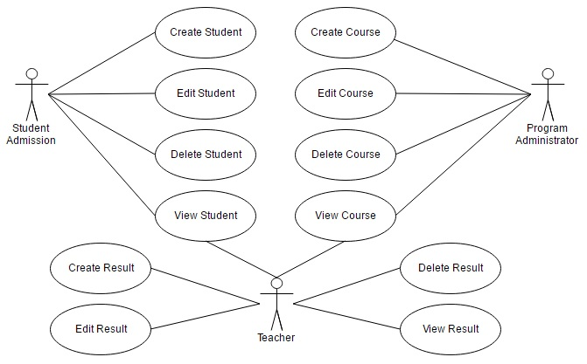
Class Diagram:

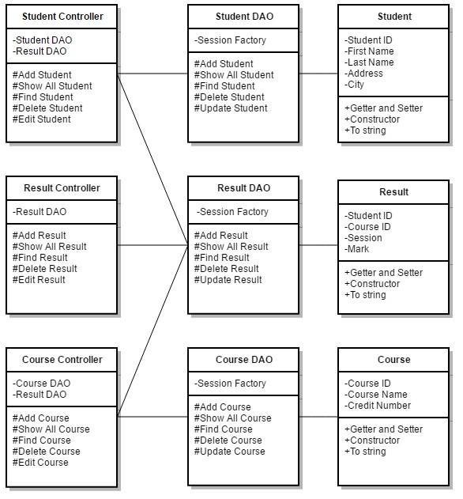

Hardware & Software Requirement :

Hardware Interfaces
- Minimum Hardware requirement
- Processor: P4 3.0 GHz
- RAM:1 GB or Higher
- Monitor
- Mouse
- Hard disk: 80 GB

Software Interfaces
- Minimum Software requirement
- Java (JSP and Servlet)
- Glassfish Server

All these types of software automatic configure inside operating system after installation it having Java, MySQL, Apache and operating system base configuration file, it doesn’t need to configure manually.
]

Implementation and Testing :

Black-Box Testing:

Black Box Testing, also known as Behavioral Testing, is a software testing method in which the internal structure/ design/ implementation of the item being tested is not known to the tester. These tests can be functional or non-functional, though usually functional.

This can be following way:

- Input interfacing
- Processing
- Output interfacing

This method is named so because the software program, in the eyes of the tester, is like a black box; inside which one cannot see. This method attempts to find errors in the following categories:

- Incorrect or missing functions

- Interface errors

- Errors in data structures or external database access

- Behavior or performance errors

- Initialization and termination errors

White-Box Testing:

White Box Testing ,also known as Clear Box Testing, Open Box Testing, Glass Box Testing, Transparent Box Testing, Code-Based Testing or Structural Testing is a software testing method in which the internal structure/ design/ implementation of the item being tested is known to the tester.

The tester chooses inputs to exercise paths through the code and determines the appropriate outputs. Programming know-how and the implementation knowledge is essential.

White box testing is testing beyond the user interface and into the nitty-gritty of a system.
This method is named so because the software program, in the eyes of the tester, is like a white/ transparent box; inside which one clearly sees.

